1. Clone the Repository
First, clone the project repository to your local machine:
git clone https://github.com/Vennilavan12/Brain-Tasks-App.git
cd Brain-Tasks-App

2. Docker Container Setup

2.1 Create a Dockerfile
Create a file named Dockerfile in the project root with the following content:
Docker container
Create a Dockerfile
FROM nginx:alpine
RUN rm -rf /usr/share/nginx/html/*
COPY dist/ /usr/share/nginx/html/
EXPOSE 80
CMD ["nginx", "-g", "daemon off;"]

3. Push Docker Image to AWS ECR

3.1 Authenticate Docker to ECR
Run the following command to log in to your AWS Elastic Container Registry (ECR):
aws ecr get-login-password --region ap-south-1 | docker login --username AWS --password-stdin 517149106120.dkr.ecr.ap-south-1.amazonaws.com
docker build -t project1 .
docker tag project1:latest 517149106120.dkr.ecr.ap-south-1.amazonaws.com/project1:latest

docker push 517149106120.dkr.ecr.ap-south-1.amazonaws.com/project1:latest

3.2 Verified
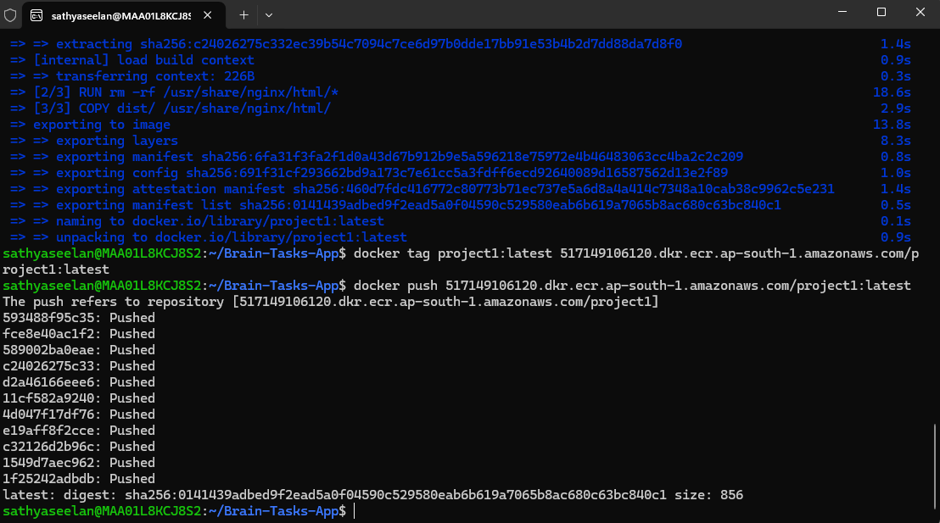
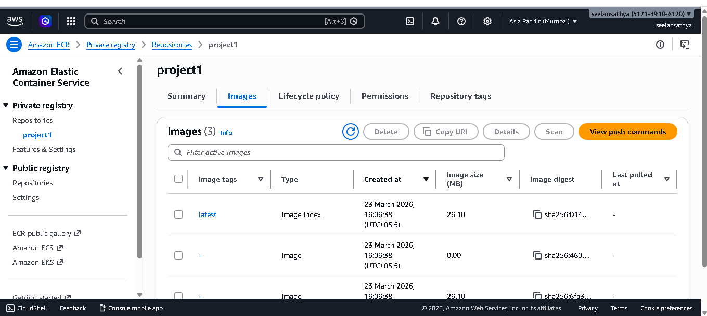

Local MACHINE I create buildspec.yml,deployment.yaml and service.yaml

Bulidspec.yml
version: 0.2

phases:
pre_build:
commands:
- echo Logging into ECR
- aws ecr get-login-password --region ap-south-1 | docker login --username AWS --password-stdin 517149106120.dkr.>

build:
commands:
- docker build -t project1 .
- docker tag project1:latest 517149106120.dkr.ecr.ap-south-1.amazonaws.com/project1:latest

post_build:
commands:
- docker push 517149106120.dkr.ecr.ap-south-1.amazonaws.com/project1:latest
Deployment.yaml
version: 0.2

phases:
pre_build:
commands:
- echo Logging into ECR
- aws ecr get-login-password --region ap-south-1 | docker login --username AWS --password-stdin 517149106120.dkr.>

build:
commands:
- docker build -t project1 .
- docker tag project1:latest 517149106120.dkr.ecr.ap-south-1.amazonaws.com/project1:latest

post_build:
commands:
- docker push 517149106120.dkr.ecr.ap-south-1.amazonaws.com/project1:latest
Service.yaml
version: 0.2

phases:
pre_build:
commands:
- echo Logging into ECR
- aws ecr get-login-password --region ap-south-1 | docker login --username AWS --password-stdin 517149106120.dkr.>

build:
commands:
- docker build -t project1 .
- docker tag project1:latest 517149106120.dkr.ecr.ap-south-1.amazonaws.com/project1:latest

post_build:
commands:
- docker push 517149106120.dkr.ecr.ap-south-1.amazonaws.com/project1:latest

IAM Role & Permissions
Create the IAM
Attach policies:
- AmazonS3FullAccess
- AWSCodeDeployRole
- ADD ECR
Json policy
{
"Effect": "Allow",
"Action": [
"ecr:GetAuthorizationToken",
"ecr:BatchCheckLayerAvailability",
"ecr:CompleteLayerUpload",
"ecr:UploadLayerPart",
"ecr:InitiateLayerUpload",
"ecr:PutImage",
"ecr:BatchGetImage"
],
"Resource": "*"
}

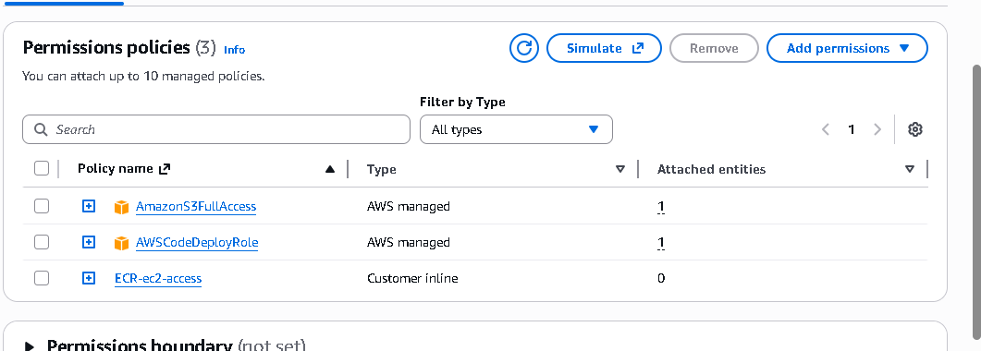

AWS EC2 Setup and Kubernetes Environment

4.1 Launch an EC2 Instance
- Log in to your AWS account.
- Launch an EC2 instance (e.g., Ubuntu 22.04 LTS).
- Connect to the instance
- I don’t have account limit for EKS so install minikube in my EC2 instance

4.2 Install Docker
Update package lists and install Docker:
sudo apt update
sudo apt install docker.io -y
sudo usermod -aG docker ubuntu
sudo service docker start
sudo systemctl start docker
sudo systemctl enable docker

4.3 Install Kubectl
curl -LO https://dl.k8s.io/release/v1.29.0/bin/linux/amd64/kubectl
chmod +x kubectl
sudo mv kubectl /usr/local/bin/
kubectl version –client
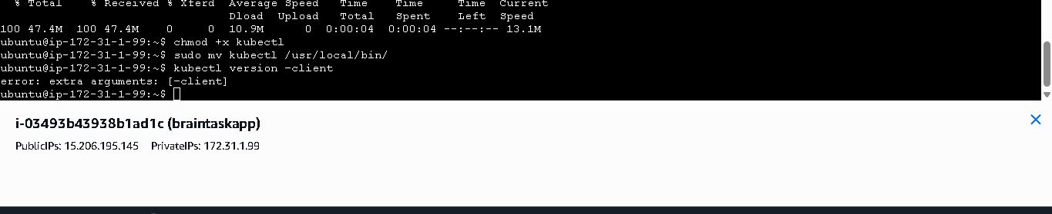

4.4 Install Minikube
Download and install Minikube:
curl -LO https://github.com/kubernetes/minikube/releases/latest/download/minikube-linux-amd64
sudo install minikube-linux-amd64 /usr/local/bin/minikube && rm minikube-linux-amd64
sudo usermod -aG docker $USER && newgrp docker
minikube start --driver=docker --memory=1800 --cpus=2
kubectl get nodes
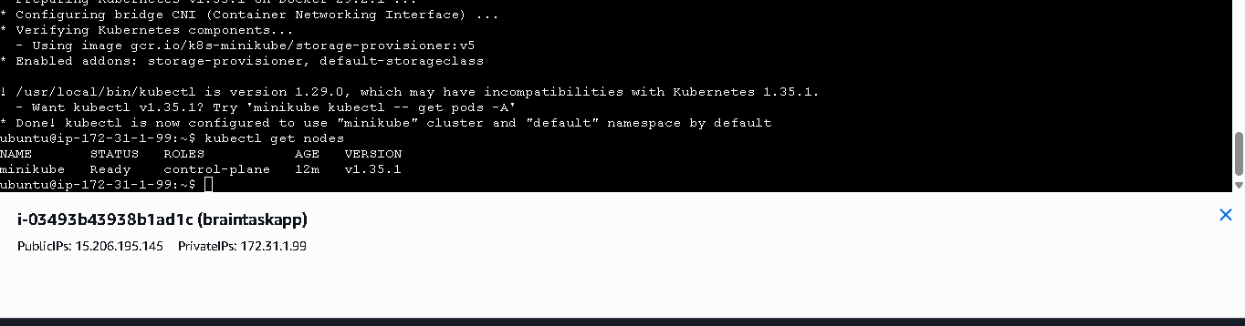

Allow Minikube to Pull from ECR
sudo apt update
curl "https://awscli.amazonaws.com/awscli-exe-linux-x86_64.zip" -o "awscliv2.zip"
sudo apt install unzip
unzip awscliv2.zip
sudo ./aws/install
aws –version
codedeployment agent
sudo apt install -y ruby wget unzip
sudo wget https://aws-codedeploy-ap-south-1.s3.ap-south-1.amazonaws.com/latest/install
sudo chmod +x ./install
sudo ./install auto
EC2 access ECR
EC2 Instance IAM Role – “AmazonEC2ContainerRegistryFullAccess”attached
aws ecr get-login-password --region ap-south-1 \
| docker login \
--username AWS \
--password-stdin 517149106120.dkr.ecr.ap-south-1.amazonaws.com
kubectl create secret docker-registry ecr-secret \
--docker-server=517149106120.dkr.ecr.ap-south-1.amazonaws.com \
--docker-username=AWS \
--docker-password=$(aws ecr get-login-password --region ap-south-1)
secret/ecr-secret created

6.3 Push EC2 and Local Project Files to GitHub
Push your project, including EC2-related files or Kubernetes manifests, to GitHub
git init
git add .
git commit -m "Build pipeline"
git branch -M main
git remote set-url origin https://github.com/Sathyaseelan95/Brain-task-app.git
git push -u origin main
7. create the code deploy application
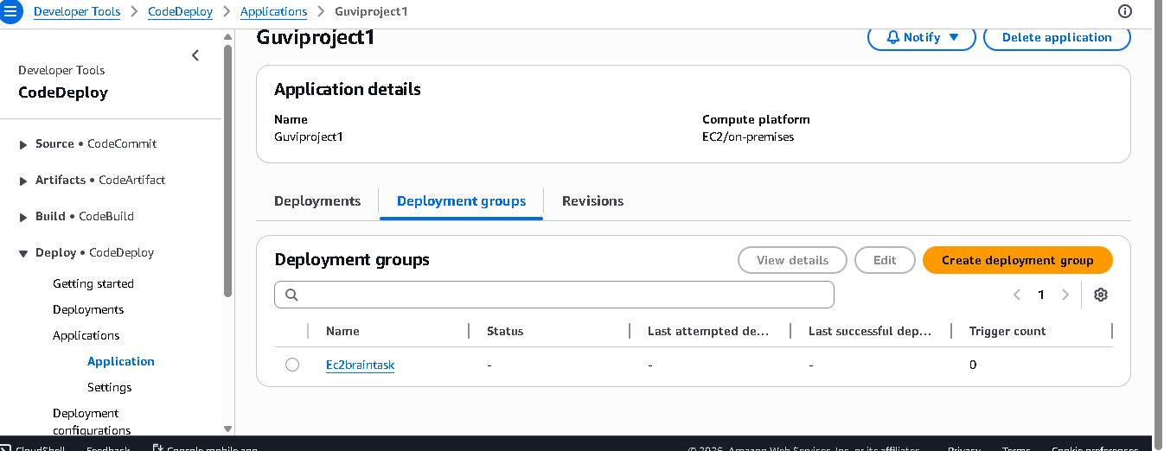

7.1 Create deploymentgroup and attached the IAM role to run the pipeline
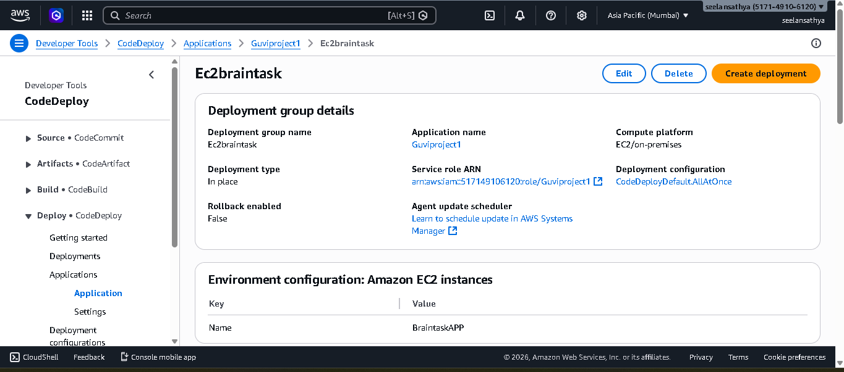
Create the code Pipeline and give access for my github account and attached codedeploy application
7.3 But my pipeline is failed because of my Account limit exceed.
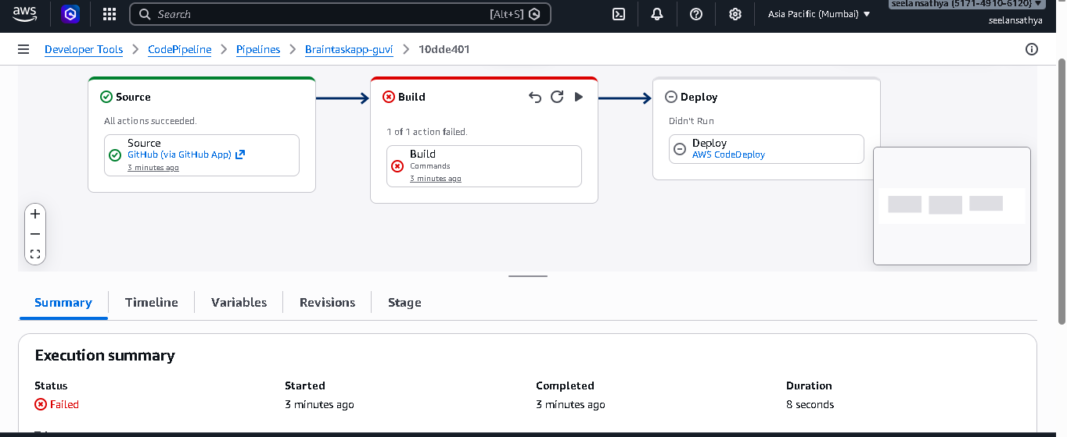
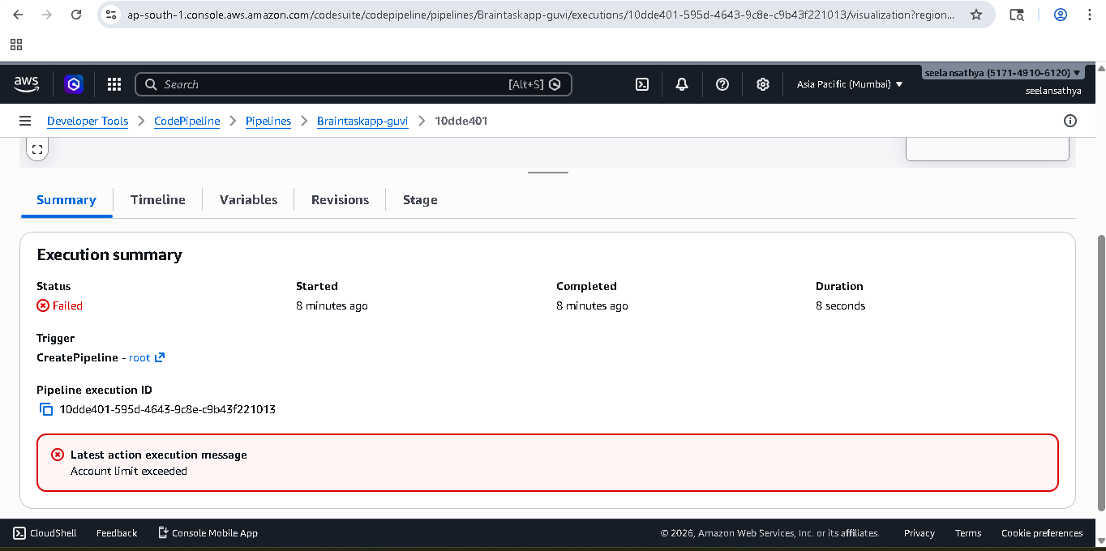

Code build error:
8.1 I run manually run the kubernets cluster
kubectl apply -f deployment.yaml
kubectl apply -f service.yaml
kubectl get pods
kubectl get svc
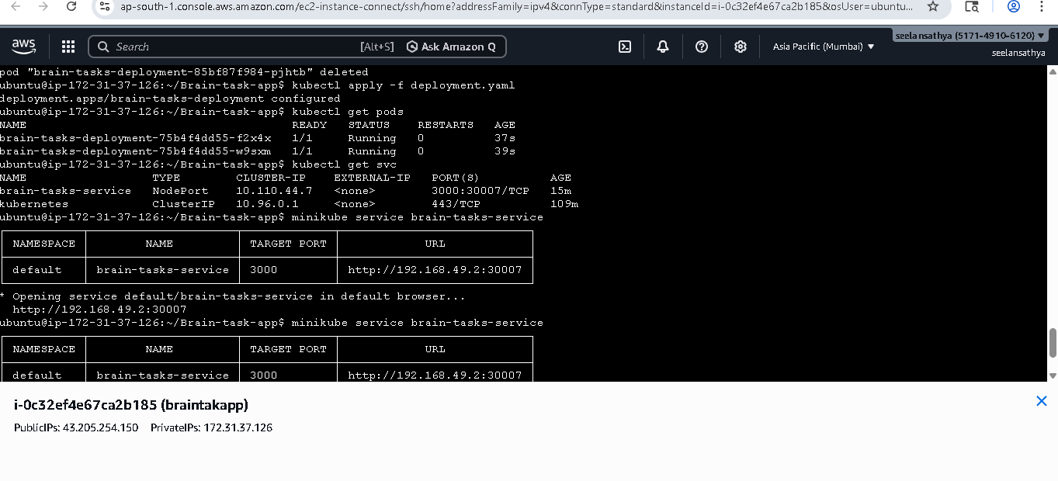
kubectl port-forward service/brain-tasks-service 3000:80 --address 0.0.0.0
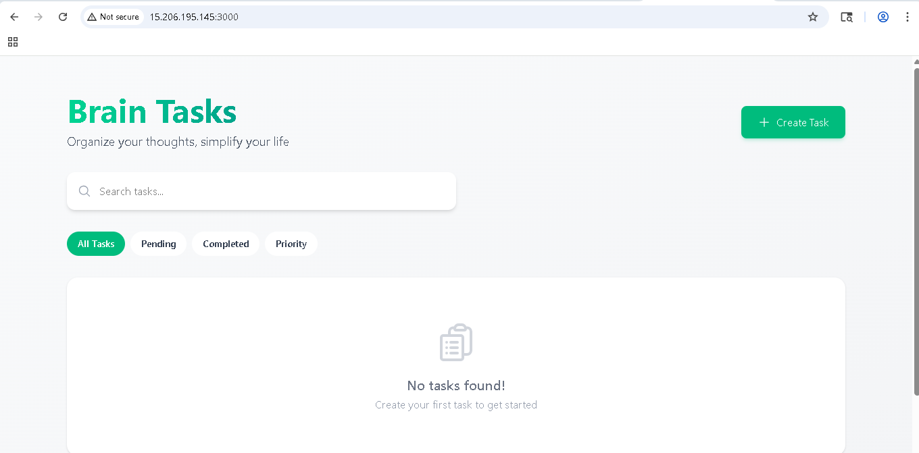

9.CloudWatch Logging
Install cloudwatch in my EC2 instance
wget https://s3.amazonaws.com/amazoncloudwatch-agent/ubuntu/amd64/latest/amazon-cloudwatch-agent.deb
sudo dpkg -i amazon-cloudwatch-agent.deb
touch /home/ubuntu/baintask.log
chmod 644 /home/ubuntu/baintask.log
sudo /opt/aws/amazon-cloudwatch-agent/bin/amazon-cloudwatch-agent-config-wizard (config step done)
sudo mkdir -p /var/log/brain
sudo touch /var/log/brain/baintask.log
chmod 666 /var/log/brain/baintask.logs

sudo systemctl start amazon-cloudwatch-agent
sudo systemctl enable amazon-cloudwatch-agent
sudo systemctl status amazon-cloudwatch-agent
sudo /opt/aws/amazon-cloudwatch-agent/bin/amazon-cloudwatch-agent-config-wizard
• OS: Linux
• Logs: Yes
• Log file path: /home/ubuntu/braintask.log
• Log group name: brain-tasks-logs
sudo systemctl start amazon-cloudwatch-agent
sudo systemctl enable amazon-cloudwatch-agent
sudo nano /opt/aws/amazon-cloudwatch-agent/etc/amazon-cloudwatch-agent.json
{
"logs": {
"logs_collected": {
"files": {
"collect_list": [
{
"file_path": "/var/log/brain/baintask.log",
"log_group_name": "Braintaskalert",
"log_stream_name": "braintaskapp",
"timezone": "UTC"
}
]
}
}
}
}

9.1 log group created
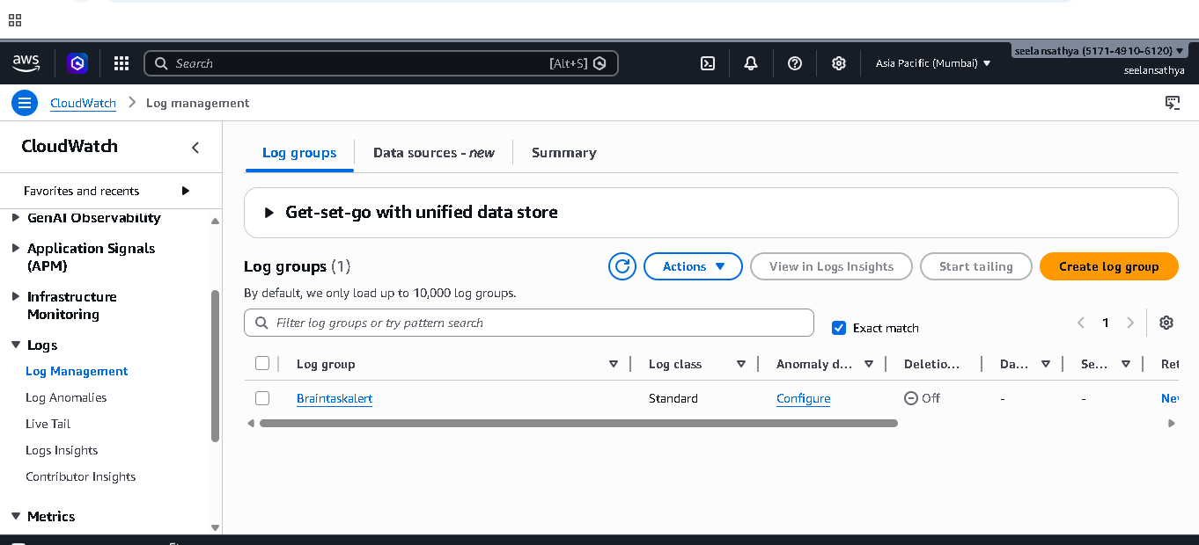

9.2 Log event
